**LAST FIVE MINIMUM VALUES**

**SCENARIO:** We Have “n” -Number of Records a XML-file but we need to take only least 5 value on entire records.

**ACTIVITIES: 1.Timer**

**2.Read File**

**3.parseXML**

**4.RenderXML**

**5.Mapper**

**6.Itrate -Loop**

**USE OF ACTIVITIES:**

**Timer:** - Receive notification Starts a process on the time specified and act as a process starter.

**Read File:** -The Read File activity is used to read a file and place its contents into

the activity’s output.

**Parse data:-**

The Parse Data activity takes a text string or input from a file and processes it, turning it into a schema tree based on the specified Data Format shared configuration. You can use any mechanism to obtain or create a text string for processing. For example, you can use the Read File activity to obtain text from a file, or you can retrieve a text field. You can also specify a text file to read using this activity.

**Render data:-**

The Render Data activity takes an instance of a data schema and renders it as a text string. The schema processed is based on a specified Data Format shared configuration. You may wish to use this activity in a number of situations.

**Mapper:-**

The Mapper activity adds a new process variable to the process definition. This variable can be a simple datatype, a TIBCO ActiveEnterprise schema, an XML schema, or a complex structure. You can map data values from the current list of process variables to the elements of the variable added with the Mapper activity .

**Iterate Loop:-** Iterate Loop an Iterate loop repeats the series of grouped activities once for every item in an existing sequence or list. The list can be items of any data type.

**PROCEDURE:**

1. Create a Process and place activites as below.

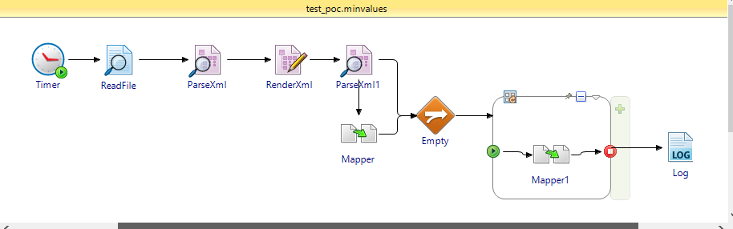

1. Configure Read file In General tab as below.

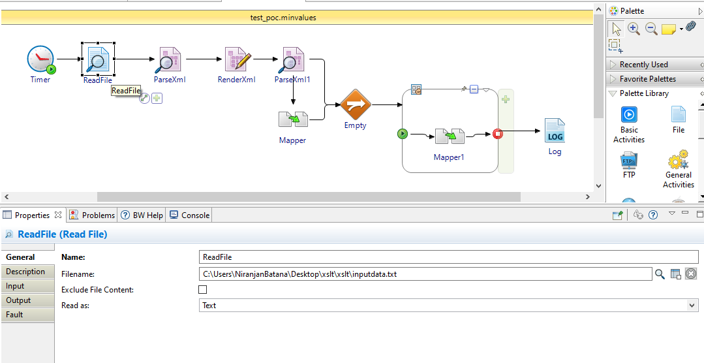

1. Create a schema in ouput editor or in schema folder as per the input data.

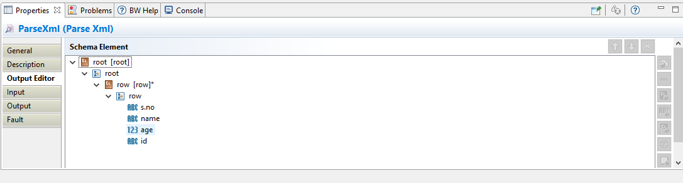

1. After That Map the Read file output to parse xml input.

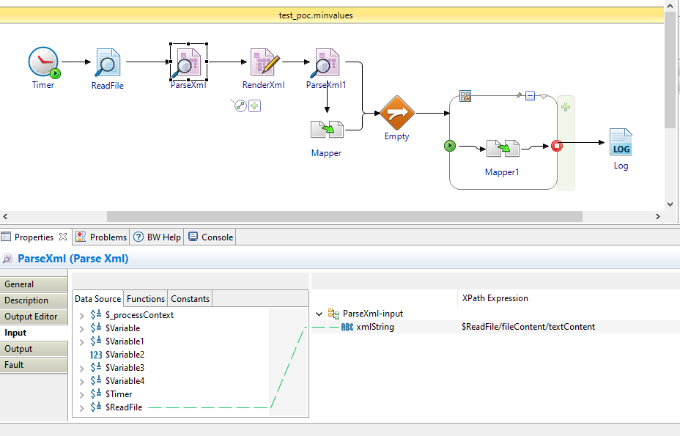

Then we can see the parse xml output as the xsd tree based specified data as below.

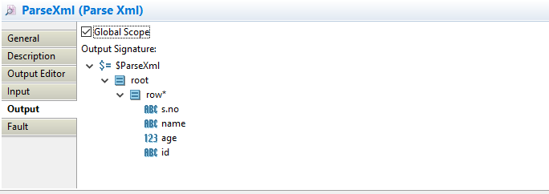

1. Give the schema in output editor of render xml as per requirement in this scenario taken same parse xml schema

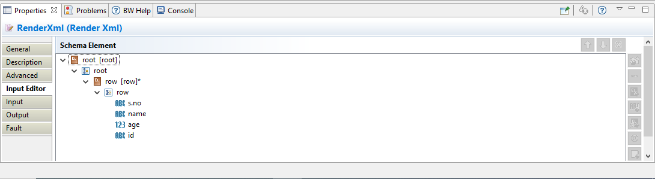

1. Map the parse xml output to render xml input with grouping and sorting as below

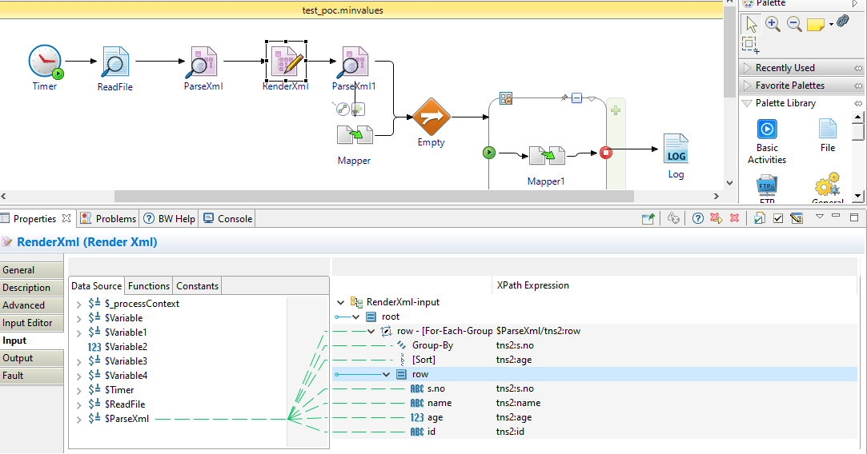

1. parse the data we take from render XML and give same parse XML schema in output editor.

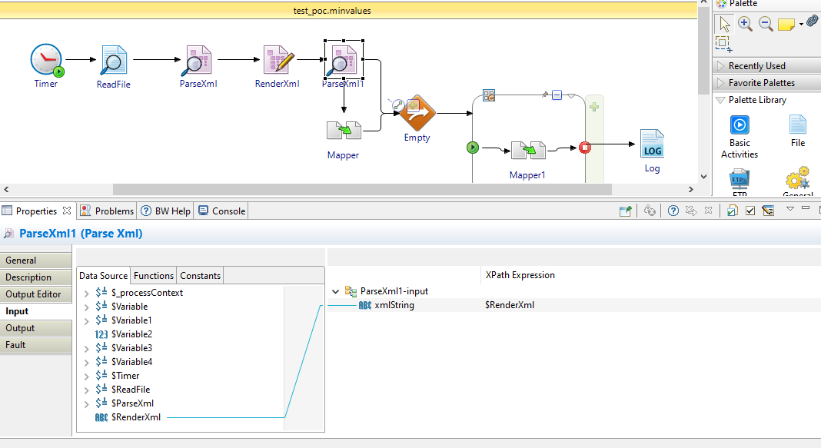

1. Take Mapper Activity and give schema in input editor(in this scenario taken only two elements for an example)

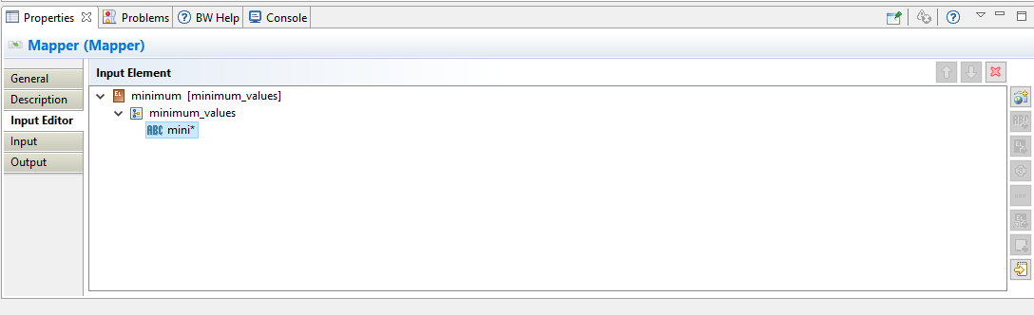

1. Map input as below which is data coming from the parsexml(for best practice do duplicate on repating element(mini* click right key and select duplicate) in mapper)

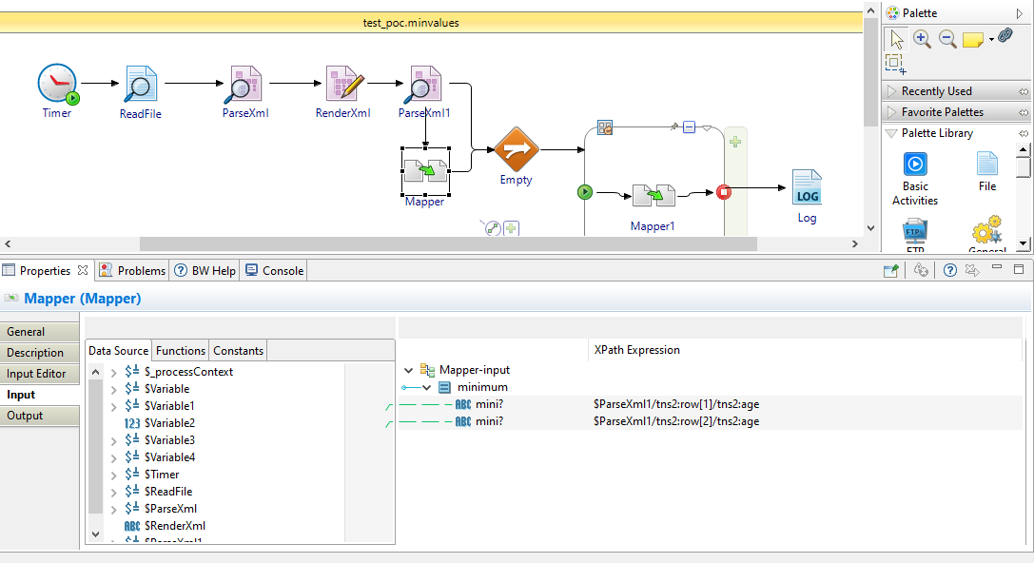

1. Set the variable list on iterate loop which is coming Mapper output data ,in that set of data take only root element.

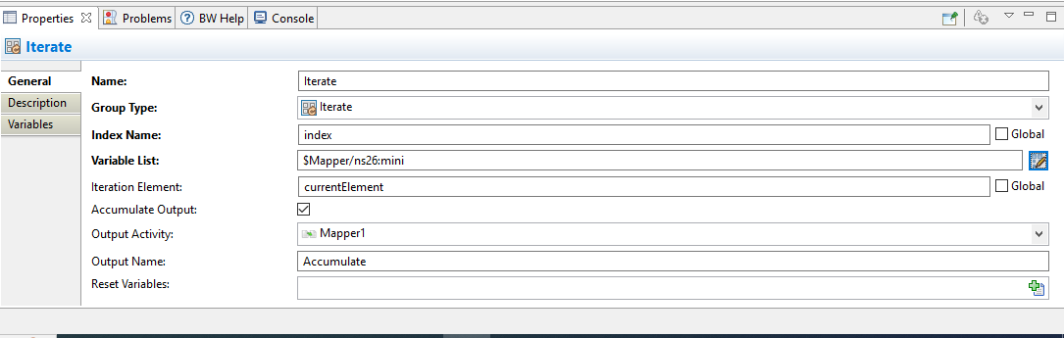

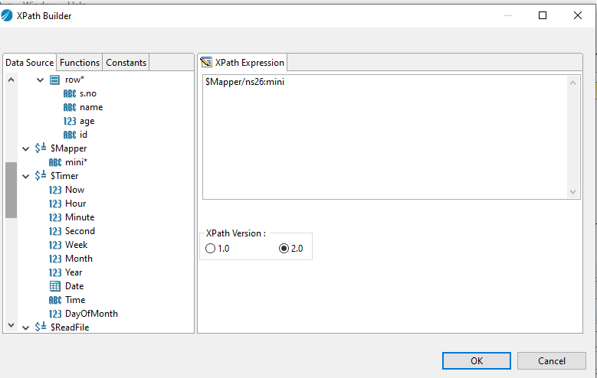

1. Next go to Mapper 1 activity give schema in input editor and create a variable with current element and write a filter condition parsexml output of condition element=variable and give the individual mapping as below.

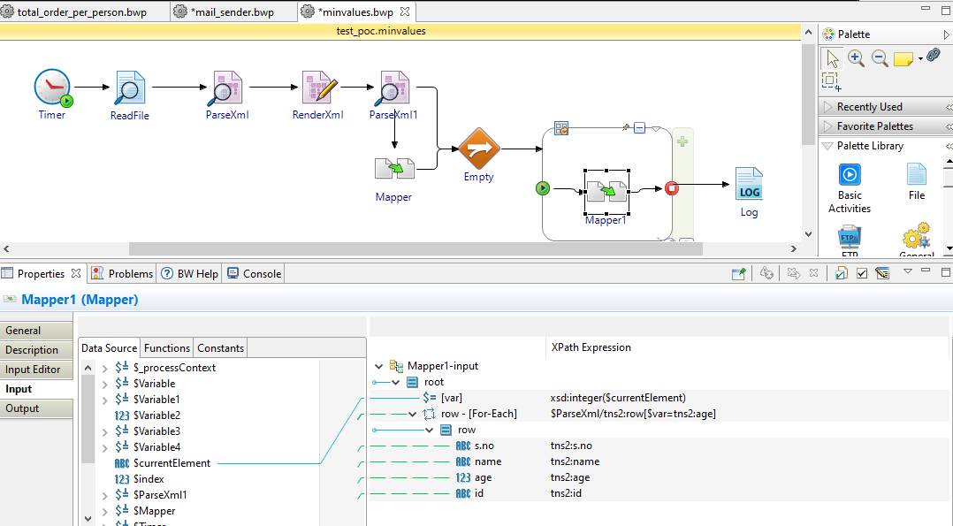

1. Next DEBUG the process we get least 5 values.(in this scenario we are getting minimum two elements of data )

